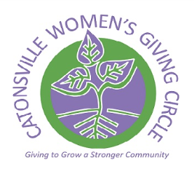
Catonsville Women’s Giving Circle
2015 Grant Application

Grant applicants must be IRS-designated nonprofit organizations whose activities strengthen the Catonsville community. Successful grantees must sign an agreement regarding the use of funds and project reporting. Non-compliance with the terms of the agreement may influence future application decisions. The completed application must be postmarked or emailed by August 1, 2015. Grants will be awarded in January, 2016.

Section I. Organizational Information. Please indicate (*) the best means of contacting your organization
Name of organization:
Organization Email:  (If available) |  | Organization Phone #:  (If available)
Address:
Website:
Contact person 1: |  | Phone #:
Email :
Contact person 2: |  | Phone #:
Email:

Section II. Nonprofit Summary. We would like to learn more about your organization and your target population, including:

Mission statement:
Geographic and demographic community served, including number served:
Most important accomplishments of the past two years:

Section III. Grant Request. Please describe in full the purpose of the grant and if funded, how it would strengthen the Catonsville community.

Amount requested: $
Grant will be used to:
Grant will strengthen the greater Catonsville community by:

Supporting Documentation
Please attach the following documents to your application and submit by Aug 1, 2015 to Catonsvillegiving@gmail.com . Applications also can be mailed to:
Catonsville Women’s Giving Circle P.O. Box 3263, Catonsville, MD 21228
Postal applications must be postmarked by Aug 1, 2015.

1. IRS designation letter
2. Signed copy of W-9 tax form (available at www.irs.gov/pub/irs-pdf/fw9.pdf)
3. Organization budget for the current year
4. Budget for the program for which you seek funding
5. Board roster (if available)
6. Latest annual report (if available)
7. Latest newsletter (if available)
8. Photographs of the organization’s activities (if available)

